Business Development Guide
Jan 2023
The purpose of this guide is to provide business proponents and those who work with them with a tool to assist in the business development process. The guide briefly outlines this process and, more importantly, highlights many of the considerable business development and operating resources available to individuals and businesses.
.
Business Development Definition
Ideas, initiatives, and activities aimed toward enhancing business performance.
Includes:-
- Increasing revenues,
- Growth in terms of business expansion,
- Improving profitability by building strategic partnerships and.
- Making strategic business decisions.

Business Development Vision

Enhance UAE investment in knowledge.

Business Development Mission

Support investing and business activities in KU.

Objective
Review & Adjust
- All stakeholders define the strategies to address SWOT combination
- Opportunities vs Strength
- Opportunities vs Weakness.
- Threats vs Strengths.
- Threats vs Weakness
- Setup priorities
- Objectives
- Key Strategies.
- Short & Long term goals
- Operational plans
- All stakeholders review :-
- Strategies
- Goals
- Plans
- Adjust if necessary
Define Strategies
A- Support the self-sufficiency of the University in the long term by increasing the current levels of income and
B- Increase efficiency in all the university processes and develop analysis and reporting for decision-making.

Business & Development Strategic Plans Overview
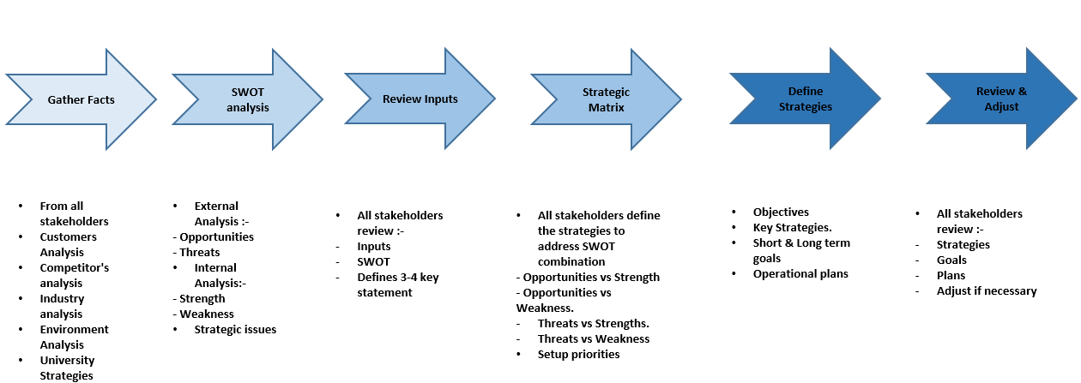

This document outlines Business Development processes that guide cross-functional activities to generate income. Over the years, the campus embarked on several activities to diversify its revenue streams, and these include consultancies, and partnerships, leveraging its technological and physical infrastructure, and expanding its footprints into new territories.

The Business Development Unit (BDU) is established within the Office of the SVP Finance and Investment, KU University. The BDU is strategically positioned on campus to develop business engagements with KU partners, industry players, international development agencies, non-governmental organizations, and other business prospects.

This policy is intended to be a partial list of all available resources. Instead, the guide outlines a process and highlights some key resources that may be helpful.

It is intended that a business proponent utilize only some resources in this model. Depending on the proponent's current phase, only some of the resources identified in this document will apply. Essential resources, which are particular to a business development project, can be identified and used according to the type and nature of the business idea.

Business development and analysis scope of work
To improve an organization's market position and achieve financial growth. Defines long-term organizational strategic goals, builds key customer relationships, identifies business opportunities, negotiates and closes business deals, and maintains extensive knowledge of current market conditions.

Business Development Areas in KU:-
A- Academic Sector
B- Commercial Sector
C- Investment Sector

The three above areas are integrated and exchangeable depending on the project stage and need, in the coming policies will cover the three business development wings and regarding the policies and procedures.

- Academic Sector

The academic sector is a concerned all activities that involve the faculties efforts within the teaching and research areas, including but not limited to the following:-
1- Continuing education activities
2- Startup projects and patents investments.
3- Scholarships and sponsorship revenue streams
4- Other academic activities such as conferences and consultancies.

- Commercial Sector

The commercial activities include all areas of using KU premises and assets in generating revenues such as:-
1- Shops and outlets rentals
2- Spaces rental activities.
3- Assets rental and services activities
4- Activities of using KU brand or names.

- Investment Sector

The Investment activities include all areas in were KU act as an investor for an extra fund that it has through its fund or from other funders:-
1- Endowment fund investment
2- KUEC and other potential newly owned companies under KU.
3- New companies result from investing in new startups and patents.

Business development general rules
1- The BDU should adhere to the general regulations and laws in Abu Dhabi and the general policies of KU.
2- Starts and commercialization activities should be in line with KU academic and research office policies.
3- Financing activities should align with the KU decree and AD DoF guidelines.
4- The business proposal and revenue agreement approval should follow the approved KU authority matrix.
5- The investment committee (sub-committee from KU BOT), considers the upper authority for all investment decisions in KU and should report to the committee every quarter.
6- Most of the revenue-generating projects rely on the KU operating unit, which will be part of the operating unit process; BDU will help the operating unit build and implement the new process.

Business Development Procedures
This document contains the Business Development Unit (BDU) procedures and day-to-day business processes.
The main activities in BDU are as follow:-

A- Pricing process of Product or service.
B- New Project Process
C- New Investment placing.
D- Reporting on running projects and investments.

A- Pricing process of Product or service
Pricing for any new service, rental or Product contain the following elements to be considered:-

- The space value and this can be determined through the sqm value provided by the independent valuator
a- The Sqm value is to be reviewed every five years to ensure it is in line with market prices.
- University overhead rate, the current approved OH rate is 30% of the service costs.
- Faculty/Staff efforts by hours, the rate calculated based on the position level divided by yearly hours.
- Assets usage rate, by dividing the book value of the asset by it is useful life (by hours)
- Direct material used, using the recent cost of materials.
- Profit margin, using the reasonable profit margin that matches the service or Product.

The pricing sheet is as follow:-
(Table A1)
 | Element | UOM | QNT | Rate | Total
1 | Staff effort | Hours | XX | XX | XX
2 | Direct Materials | Unit | XX | XX | XX
3 | Assets Usage | Hours | XX | XX | XX
4 | Space Usage | SQM | XX | XX | XX
 | Total Costs |  | XX | XX | XX
5 | Overhead | 30% | XX | XX | XX
 | Total Cost |  | XX | XX | XX
6 | Profit Margin | 10% | XX | XX | XX
 | Total |  | XX | XX | XX

Pricing procedures

The pricing procedures should have the following steps and approval:-

- Upon receiving a request from an external or internal client for a service or Product through the Business Development website, the senior Specialist arranges for an understanding meeting with the client.
- Then, the Senior Specialist arranges a meeting with the KU service provider department to discuss the cost elements and understand the service/product's entire cycle.
- After gathering all the service/product detail, Senior Specialist prepares the primary costing/pricing sheet (table A1) and review it with the Manager – BD for review.
- The final pricing sheet with the proposed terms and conditions was sent to the VP-Investments / SVP Finance & Investment for last review and approval.
- After the client signs the proposal, the senior Specialist arranges a meeting with the client to prepare the project timeline and agree on deliverables.
- After determining all the project deliverables and timelines, the client sends the PO to KU and start the project executions.

- New Project Process

1- Part of the Business development process is to liaise in the commercialization of KU IP, patent, and other business projects; this is done through the BDU team.
2- Upon receiving a request from the KU academic or research department about the need to commercialize one of the potential projects, the senior Specialist arranges for an understanding meeting with the concerned department.
3- The Senior Specialist, with the supervision of the Manager-BD, starts the preparation of the entire project study; the study elements are as follows:-
A- Prepare feasibility study (Market research - Forecasted Sales- Costing process – Capital requirements – Equity assumptions- Cash flow projections – Financials indicators [DCF- IRR-Payback] - Conclusions)
B- Developing Business Plan ( 3-5 years sales projections – entire costing process – Projected cash flow- projecting Income Statement – Projected Balance sheet).
C- Prepare a comprehensive presentation for all the project studies.

4- Manager – BD presents the final calculation to VP investment for review and approval.
5- VP- Investment gets the final approval from the SVP- of Finance & Investment, and the latter can get the Investment Committee approval if necessary.
6- VP- Investment get the final approval from the SVP- of Finance & Investment, and the latter can get the Investment Committee approval if necessary.
7- Implementing the business plan and quarterly reporting about the results to management.

- New Investment placing

The BDU provides advice for KU management regarding the opportunity for investing extra cash; the current main areas in investing are as follows:-

1- KU Endowment: The KU endowment represents a long-term fund that invests cash in supporting research and development.
2- KUEC: - Khalifa University Enterprises Company, consider the investment is of KU, were the new startup projects-subsidiaries established under KUEC.

The process of placing a new investment

1- The KU treasury team provide a monthly report about the cash status in the investment pool.
2- The senior Specialist provides the cash report to the manager BD.
3- The Manager- BD starts the study of the best investment tool that suits the size-risk maturity of the current cash.
4- The Investor search includes but is not limited to (Local commercial banks- current investment managers – Local investment government bodies)
5- After reviewing the reasonable investment that matches the risk criteria for governmental organizations (low-risk investments grade), Manager BD sends the investment proposal to the VP-Investment for review and approval.
6- VP-Investment reviews the investment proposal and gets the SVP- Finance & Investment for final approval.
7- Start placing the investment in coordination with the treasury unit in KU Finance.
8- Provide a monthly report to management.

- Reporting on running projects and investments.

Reporting under BDU should be as mentioned below:-

S | Reporting Area | Frequently | Responsible Person
1 | KU general operation revenue report | Quarterly | Manager BD
2 | Investments report | Monthly | Manager BD
3 | Projects status report | Quarterly | Manager BD
4 | Business Development achievements report | Yearly | Manager BD

